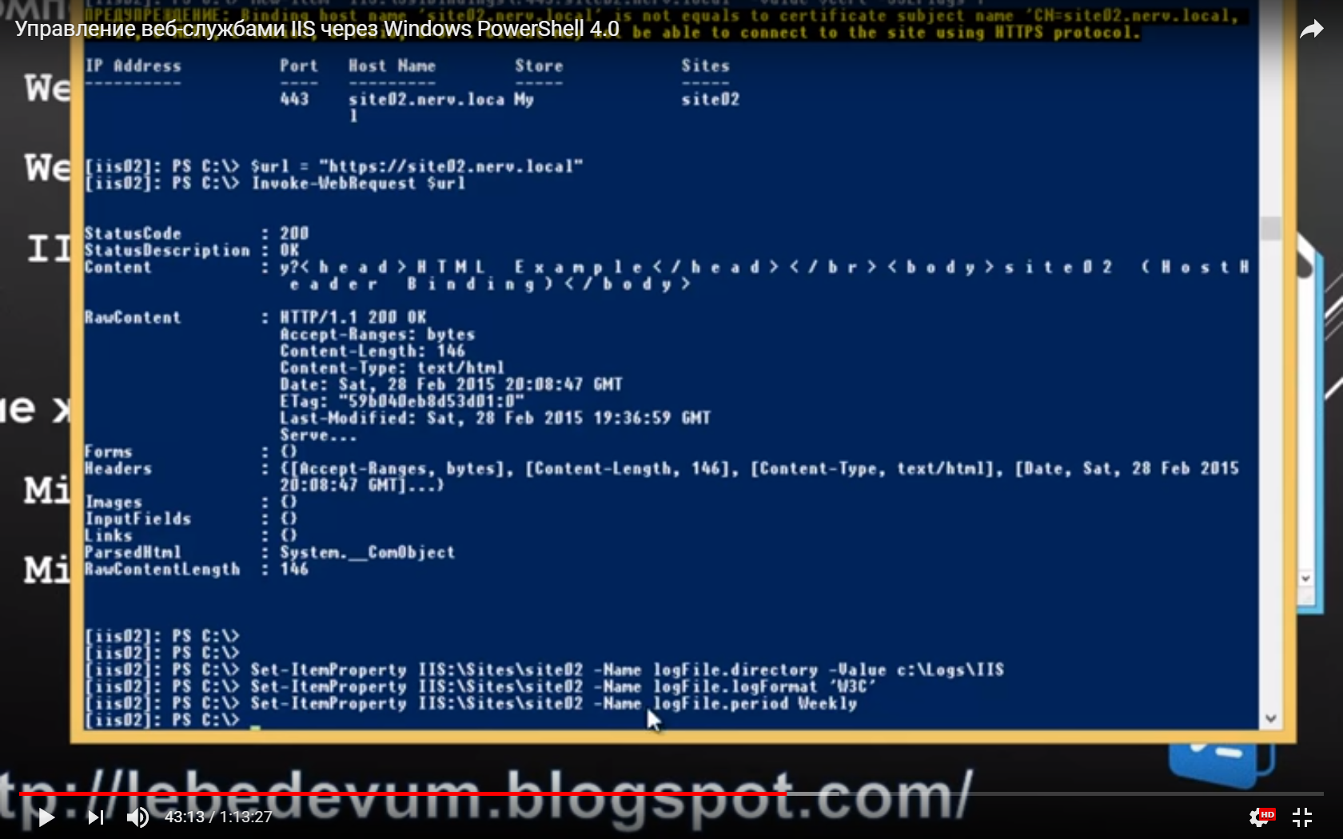

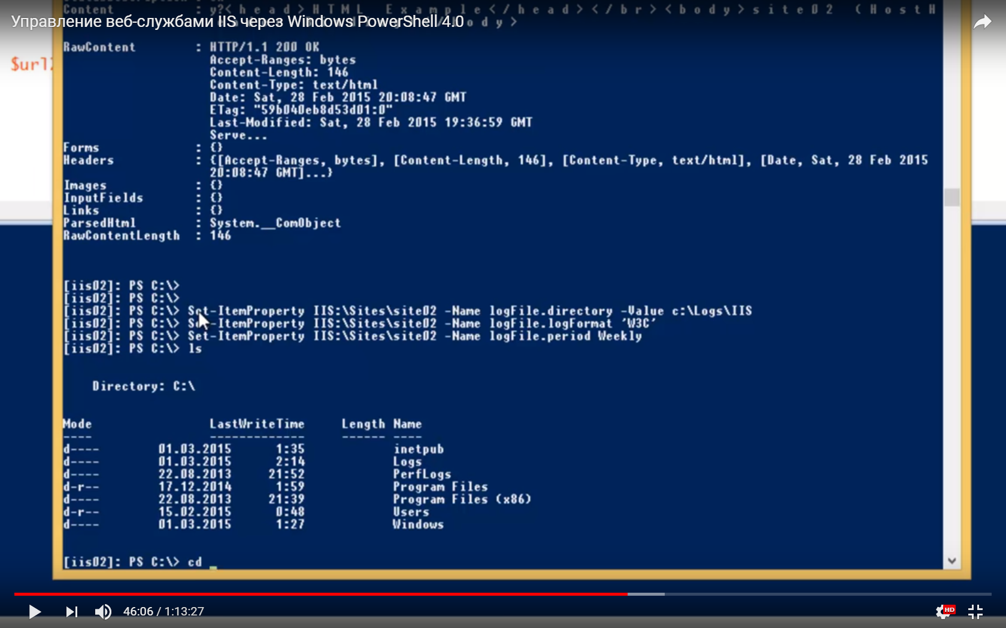

'Content

YnpaB eH1,1e Be6-cnyx6aMV1 IIS qepe3 Windows PowerShell/Å1()

c:

c:

c.

c.

c:

c:

1.

2:

1.

o:

(Content-Type, text/htnll ,

(Date, sat, 28 Feb 201S

RavContent

F orns

Headers

Images

InputF ields

Links

ParsedHtnl

RavContentLength

HTTP/I.1 200 OK

accept-Ranges: bytes

Content-length: 146

Content-Type: text/htnl

Date: sat, 28 Feb 201S GMT

ETag:

"S9b040eb8dS3d01:Ø"

Last-Hodified: sat, 28 Feb 201S GMT

Serve...

C(Accept-Ran es, bytes),

(Content-Length, 1461,

Systen._ConObject

146

Set-ItemProperty IIS:XSitesXsite02

S.k-ItenProperty IIS:XSitesXsite02

Set-ItenProperty IIS:XSitesXsite02

Is

liis02

liis02

tiis02

liis02

liis02

liis02 -

ps

-Hane logFile.directory -Value c:XLogsXIIS

-Hane logFile. logFornat 'W3C'

-Hane logFile.period Weekly

Length

Hame

inetpub

Logs

PerfLogs

Program Files

Program Files (x86)

Users

Windows

03.

201S

03.

201S

08.

2013

12.

2014

08

-2013

201S

02.

03.

201S

cd

LastWriteTine

Directory: C

de

01.

01.

22.

17.

22.

01.

fiis021: PS c:xy

14

21.

21.

-39

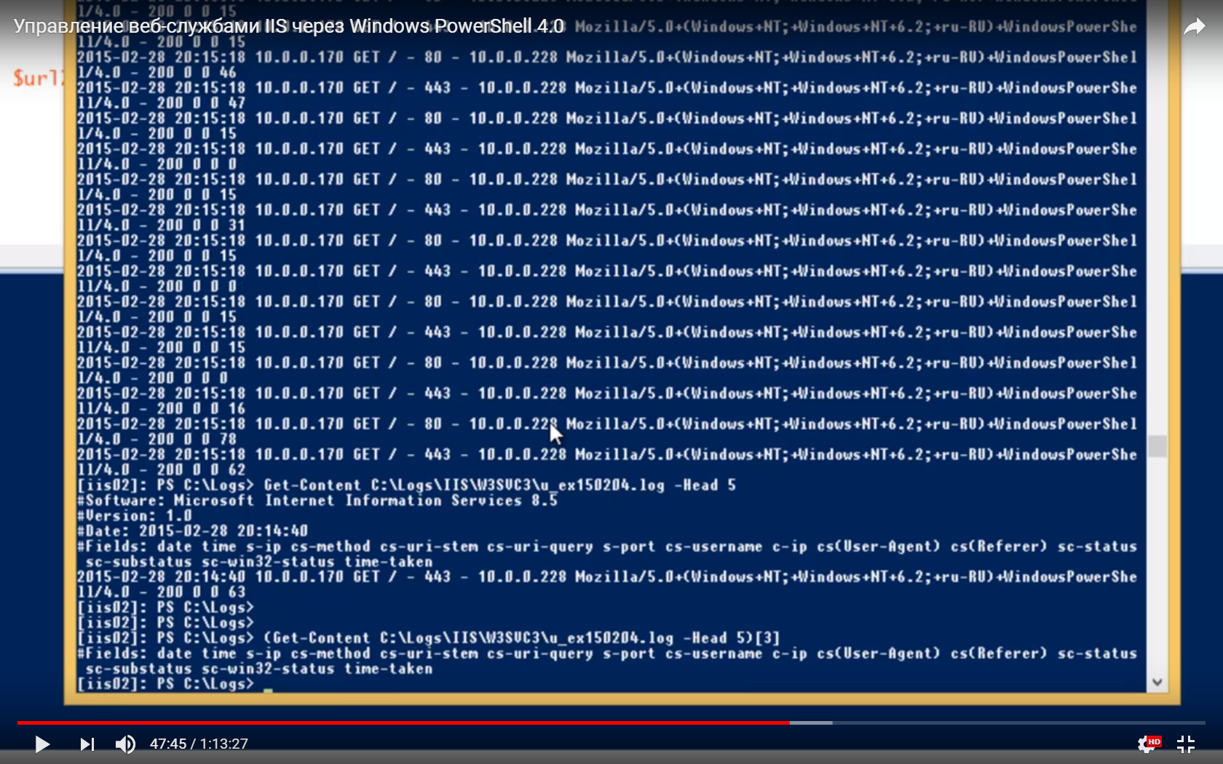

900 00 IS

YnpaBneHueJBe6cny»K6aMW IIS qepeg Windows PowerShell.4',0

Hoz i I la/S. O "lindovs ; or u -RU) 4UindovsPowerShe

10. .

10. .

o.

10. .

10. .

g.

10. .

10. .

10. .

2015-02-

1/4.0

201S-02-

11/4.0

201S-02-

1/4.0

201S-02-

11/4.0

2015-02-

1/4-0

2015-02-

11/4.0

201S-02-

1/4-0

201S-02-

11/4.0

2015-02-

1/4.0

2015-02-

11/4.0

201S-02-

1/4.0

201S-02-

11/4.0

201S-02-

1/4.0

201S-02-

11/4.0

1 i is021:

200 0 0 IS

28

200 00

28

200 0 0 47

28

200 0 0 IS

28

200 0 0 0

28

200 00 IS

28

200 0 0 31

28

200 0 0 IS

28

200 00 0

28

200 0 g 15

28

200 0 0 IS

28

200 000

28

200 0 0 16

28

200 0 0

28

200 0 0 62

10.

10.

10.

10.

10.

10.

10.

o

o

o

o

o

o

o

o

O.

g.

g.

g.

g.

g.

g.

g.

g.

g.

170

170

170

170

170

170

170

170

170

170

170

170

170

170

GET

GET

GET

GET

GET

GET

GET

GET

GET

GET

GET

GET

GET

GET

80

- 443

80

443 -

80

443

80

443 -

80

443

80

443

80

443

10.0-0.228

10.0-0.228

10.0-0.228

10.0-0.228

10.0-0.228

10.0-0.228

10.0-0.228

10.0-0.228

10.0-0.228

10.0-0.228

10.0-0.228

10.0-0.228

10.0-0.22

10.0-0.228

PS C:XLogO Get

-Content C:

XLoqsX11swgsuc3Xu -Head S

"Software: Microsoft Internet Information Services 8. S

gUersion: 1.0

'Date: 2015-02-28

'Fields: date tine s-ip cs-nethod cs-uri-sten cs-uri-query s-port cs-usernane c-ip cs(User-agent) cs(Referer) sc-status

sc-substatus sc-vin32-status tine-taken

201S-02-28 10.0-0.170 GET / - 443 - 10.0-0.228

11/4.0

200 0 0 63

liis02

PS C:XLogo

liis02

PS C:XLogO

liis02

. PS C:XLogO (Get-content log -Head

"Fields: date tine s-ip cs-nethod cs-uri-sten cs-uri-query s-port cs-usernane c-ip cs(User-agent) cs(Referer) sc-status

sc-substatus sc-vin32-status tine-taken

liis021: PS C:XLogO

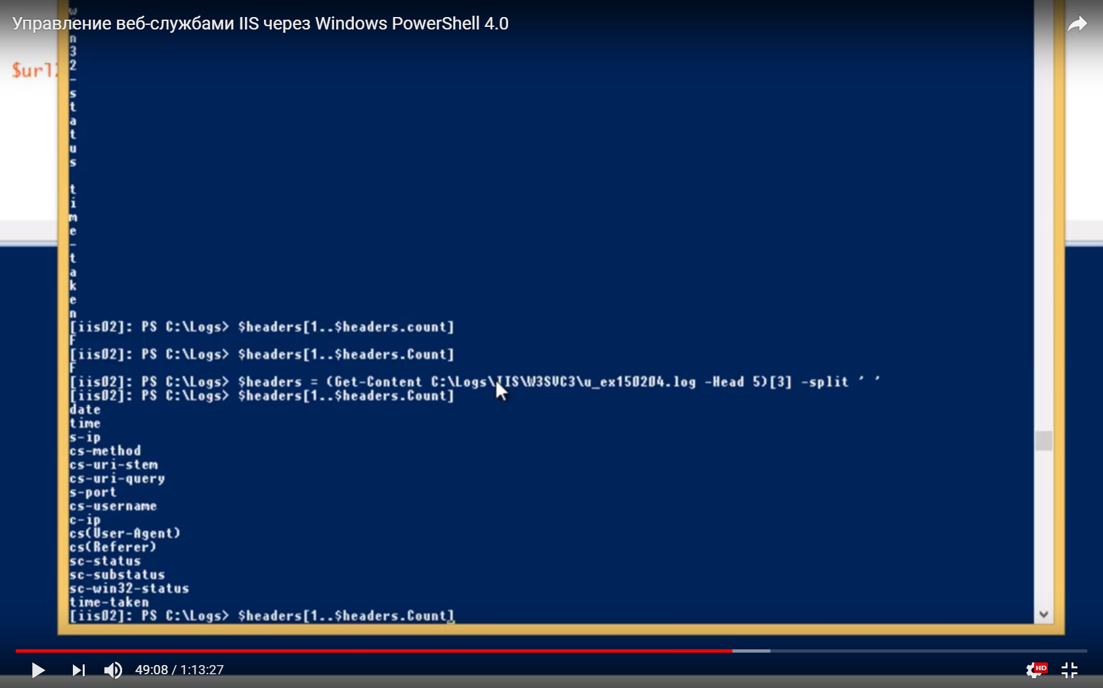

YnpaBneHMe Be6-CJIY)K6aM91 IIS qepe3 Windows PowerShell 4.0

Surl

c.

c.

c.

c.

-Head S) (31

-split

(i is021:

i is021:

liis02

(i is02

date

t ine

s-xp

cs-nethod

cs-uri-sten

cs-uri-query

s-port

cs-usernane

c-ip

• XLogs)

- XLogO

XLogs)

$headers(l..$headers.countl

.$headers.Countl

$headers

(Get-content C:XLogsX 1SW3SUC3Xu_ex1S0204.

$headerstl Count)

$headerstl..

$headers . Count

cs( User-agent)

cs(Referer)

sc-status

sc-substatus

sc-vin32-status

t ine-taken

liisØ21: PS C:XLogsY

